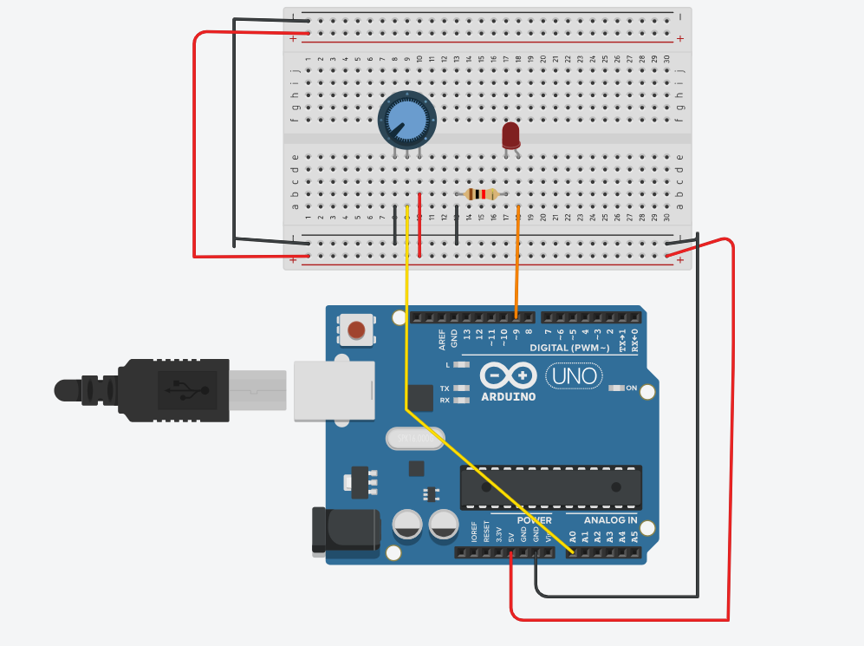
int ledPin=9;
int potPin=A0;
int potValue = 0;
int brightness = 0;

void setup() {
Serial.begin(9600);
pinMode(ledPin, OUTPUT);
}
void loop() {
potValue=analogRead(potPin);
Serial.println("potentiometer: ");
Serial.println(potValue);

brightness = map(potValue, 0, 1023, 0, 255);
analogWrite(ledPin,
brightness);

delay(100);
}

Conclusion- After rotating the potentiometer the brightness of LED changes

